**CIRCUS**

The modern circus emerged and developed during the period when western industrializing societies were undergoing transformation as a result of socio-economic modernization. Philip Astley’s popular demonstrations of trick horse-riding at Astley’s Riding School in London in 1768 constitute the origins of the modern circus. Astley interspersed his novel equestrian displays with an eclectic variety of performances such as singing, dancing, acrobatics, and juggling. Other producers soon emulated this new style of entertainment, which became known as circus. It spread swiftly to France, Russia, North America, and eventually to Britain’s settler colonies. By the 1860s the key components of the institutionalized circus were well-established. These included performances within the equestrian’s circular ring, a diverse range of acts on horseback, clowns, trained animals, and skilled physical displays such as rope or wire walking, acrobatics, juggling, aerial acts, and aerial flight with trapeze apparatus. Circuses expanded in size and experienced mass popularity with all classes of people in the western industrialized world during the period 1880-1920. Impressionist and early-Modernist artists, notably Degas, Renoir, Toulouse-Lautrec, Seurat, Roualt, Picasso, and Chagall found inspiration in the circus environment and the novel bodies of the circus’s human and animal performers.

During the late nineteenth century, the largest and most extravagant circuses developed in the United States. The Barnum and Bailey Greatest Show on Earth and the circuses of the Ringling Brothers and Adam Forepaugh produced spectacular shows and made use of the transcontinental railroad network to travel with maximum speed and efficiency between towns. Across the Atlantic, ‘Lord’ George Sanger developed the largest-ever circus organisation in Britain. The large circuses of the Harmston Brothers and the FitzGerald Brothers toured the colonial outposts of Asia and the British dominions of Australasia, utilising ocean and rail transport to efficiently move their sizable communities of humans and animals between population centres.

In their operations, and in the acts they presented, the leading circuses of the period 1880-1920 embraced many of the ideas and socio-economic processes arising from modernity. They were quick to adopt the latest scientific innovations in entertainment and transport technology. The elite physical development and skills of circus performers exemplified the modernist interest in sport, health, and physical culture. Circus acts by physically muscular and scantily clad female performers subverted gender norms. Hugely successful circus entrepreneurs such as Forepaugh, Bailey, Barnum, and Sanger exemplified the modernist interest in the development of the individual and the ability for individuals to move beyond traditional social hierarchies. The circus channelled many of the progressive ideas we now associate with modernity.

**References and Further Reading**

Arrighi, Gillian. (2012) ‘The Circus and Modernity: a commitment to “the newer” and “the newest,”’ *Journal of Early Popular Visual Culture* 10.2: 169-185.

Assael, Brenda. (2005) *The Circus and Victorian Society*, Charlottesville: University of Virginia Press.

Davis, Janet M. (2002) *The Circus Age: Culture & Society under the American Big Top*, Chapel Hill: University of North Carolina Press.

‘The First Circus: Philip Astley,’ Victoria and Albert Museum, <http://www.vam.ac.uk/content/articles/t/the-first-circus/>.

May, Earl Chapin. (1932) *The Circus from Rome to Ringling*, New York: Duffield and Green.

Tait, Peta. (2005) *Circus Bodies: Cultural Identity in Aerial Performance*, Milton Park, Oxon: Routledge.

**Gillian Arrighi, University of Newcastle**

**Recommended Illustrations**

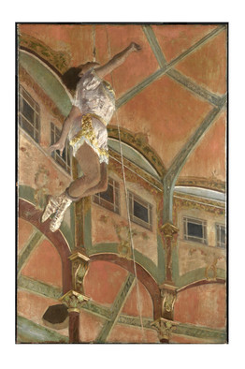

**Edgar Degas, *Miss La La at the Cirque Fernando* (1879).**

[Available at: <http://www.nationalgallery.org.uk/paintings/hilaire-germain-edgar-degas-miss-la-la-at-the-cirque-fernando>]

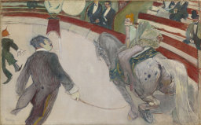

**Henri Toulouse-Lautrec, *Au Cirque Fernando, l’écuyère* (1888).**

[Available at: <http://www.artic.edu/aic/collections/artwork/16146>]

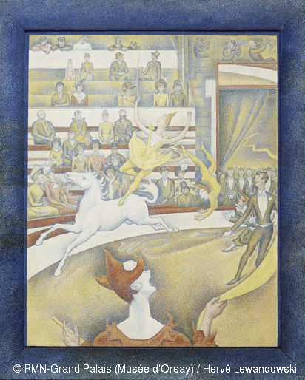

**Georges Seurat, *Circus* (1890-91).**

[Available at: <http://www.musee-orsay.fr/en/collections/works-in-focus/painting.html?no_cache=1&zoom=1&tx_damzoom_pi1%5BshowUid%5D=4045>]

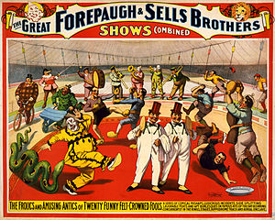

**An Adam Forepaugh and Sells Brothers’ Circus poster, 1899.**

[Available at: <http://en.wikipedia.org/wiki/Adam_Forepaugh>]